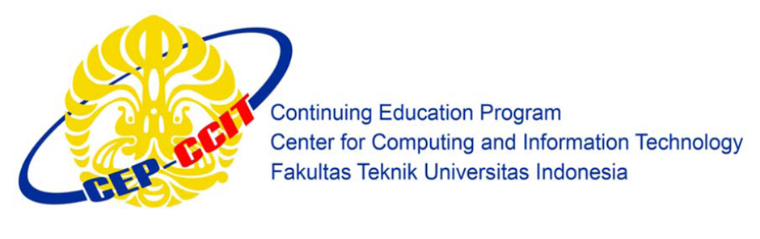

**Information Search and Analysis Skills**

**(ISAS)**

**ANALYZE WINDOWS 10 OPERATING SYSTEM**

Faculty :

**Tirta Akdi Toma Mesoya Hulu**

Written by :

**Christian Frans Mukuan**

**Deyaninta Ekabriela Permata**

**Mufadhal Faraz Addhifa**

Class :

**1CC6**

**Continuing Education Center for Computing and Information Technology Faculty of**

**Engineering, University of Indonesia**

**Kampus Baru UI Depok 16424**

# **PREFACE**

First of all, thanks to Allah SWT because we can completed this ISAS task both in the form of presentation. We want to deliver sincere especially for Mr. Tom faculty and another faculty who always help. Thank you also to fellow students who have supported, and also thank you for being fellow workers in the education at CCIT-FTUI.

The ISAS paper entitled 'Analyze Windows 10 Operating System ' the writers submits as ISAS's 2019 task requirements.

Hope of the writers, hopefully this paper can be useful for all so that it can add knowledge and insight. The writers realize that this paper is far from perfect. Therefore, the writers expect all suggestions and criticisms from readers who are constructive for the perfection of this paper.

Finally, hopefully this paper can provide many benefits for the readers.

Depok, September 2019

Writers

**TABLE OF CONTENTS**

**PREFACE** i

**TABLE OF CONTENTS** ii

**TABLE OF FIGURE** iii

**TABLE OF TABLES** iv

**CHAPTER I INTRODUCTIONS** 1

I.1. Background 1

I.2. Purpose of Writing 1

I.3. Problem Domain 1

I.4. Learning Methodology 1

I.5. Writing Framework 2

**CHAPTER II BASIC THEORY** 3

II.1. Definition of Operating System 3

II.2. Ordinal of Windows Operating System 3

II.3. Minimum System Requirements of Windows 10 4

II.4. Definition of Windows 10 4

II.5. Describes History of Windows 10 4

**CHAPTER III PROBLEM ANALYSIS** 16

III.1. Edition of Windows 10 16

III.2. Advantage and Disadvantage Windows 10 17

III.3. Features of Windows 10 17

**CHAPTER IV CONCLUSION AND SUGGESTION** 20

IV.1 Conclusion 20

IV.2 Suggestion 20

**BIBLIOGRAPHY** 21

**TABLE OF FIGURE**

Figure 2.1 Logo of Windows………………………………………………………………….3

Figure 2.2 Windows 1.0……………………………………………………………………….4

Figure 2.3 Windows 2.0……………………………………………………………………….5

Figure 2.4 Windows 3.0……………………………………………………………………….6

Figure 2.5 Windows 3.1……………………………………………………………………….6

Figure 2.6 Windows NT 3.x…………………………………………………………………...7

Figure 2.7 Windows 95………………………………………………………………………..8

Figure 2.8 Windows NT 4.0…………………………………………………………………..8

Figure 2.9 Windows 98………………………………………………………………………..9

Figgure 2.10 Windows 2000…………………………………………………………………10

Figure 2.11 Windows ME……………………………………………………………………10

Figure 2.12 Windows XP…………………………………………………………………….11

Figure 2.13 Windows Vista…………………………………………………………………..12

Figure 2.14 Windows 7………………………………………………………………………12

Figure 2.15 Windows 8………………………………………………………………………13

Figure 2.16 Windows 8.1…………………………………………………………………….14

Figure 2.17 Windows 10……………………………………………………………………..14

Figure 3.1 Timeline…………………………………………………………………………..17

Figure 3.2 Share a Picture……………………………………………………………………18

Figure 3.3 Your Phone……………………………………………………………………….18

Figure 3.4 Add Emoji………………………………………………………………………...19

Figure 3.5 Notifications………………………………………………………………………19

# **TABLE OF TABLES**

Table 3.1 Advantage and Disadvantage……………………………………………………...17

**CHAPTER IV**

**CHAPTER I INTRODUCTIONS**

1. **Background**

Technological progress in the current era is developing very rapidly, supported by the increasing needs of today's society which is very dependent on technology so that the needs can be met easily and quickly. The development of computer technology is one example of technological progress that makes humans superior in the future.

One of them is the Windows Operating System. Windows is part of the operating system produced by Microsoft as part of the Windows NT operating system family. The Microsoft company is led by William Bill Gates. Windows 10 is an improvement from Windows 8.1. This version released to the public on July 29, 2015. Windows 10 has stronger security and more new features. This feature makes Windows 10 more attractive and lighter than previous versions.

1. **Purpose of Writing**

The purpose of writing a paper about the Windows 10 operating system is:

* + 1. To work on tasks related to the Operating System
    2. To learn more about Windows 10

1. **Problem Domain**

As for the problem of writing this ISAS are

1. Describes Definition Windows 10
2. Describes History of Windows
3. Describes Editions of Windows 10
4. Describes Advantages and disadvantages of Windows 10
5. **Learning Methodology**
   * 1. **Method Library**

The method used in writing this ISAS paper is by searching for information from reference sources contained on the online sites related to the information contained in this ISAS discussion.

* + 1. **Discussion**

Obtain complete data by collecting it through various sources of information available on the internet to make ISAS papers.

1. **Writing Framework**

**Chapter I Introduction**

1. Background
2. Purpose of Writing
3. Problem Domain
4. Learning Methodology
5. Writing Framework

**Chapter II Basic Theory**

1. Definition of Operating System
2. Ordinal of Windows Operating System
3. Minimum System Requirements of Windows 10
4. Describes Definition Windows 10
5. Describes History of Windows

**Chapter III Problem Analysis**

1. Describes Editions of Windows 10
2. Describes Advantages and disadvantages of Windows 10
3. Describes Features of Windows 10

**Chapter IV Conclusion and Suggestion**

1. Conclusion
2. Suggestion

# **CHAPTER II BASIC THEORY**

1. **Definition of Operating System**

Operating System (OS) is software with the task of controlling and managing hardware as well as basic system operations, including running application software such as data processing programs that can be used to facilitate human activities[1].

For hardware functions such as input, output, and memory allocation, the operating system acts as an intermediary between programs and computer hardware. The operating system we can use such as on Smartphones, Tablets, Laptops, Desktop Computers[2].

The computer operating system is the first layer of software that is placed on the computer's memory (hard disk) when the computer is turned on. Whereas other software is run after the Computer Operating System runs, and the Operating System will perform general core services for the software. These common core services are disk access, memory management, task scheduling, and user interfaces. So that each software no longer needs to perform common core tasks, because it can be served and performed by Operating System.

1. **Ordinal of Windows Operating System**

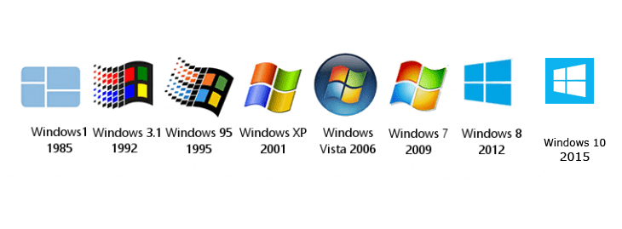

**Figure 2.1 Logo of Windows**

**(REF :** [**https://www.conspros.app/2019/06/21/microsoft-windows-version-history/**](https://www.conspros.app/2019/06/21/microsoft-windows-version-history/)**)**

Windows operating system has existed since 1985, the following is an ordinal of Windows operating systems. Windows 1.0 (*Nov 20, 1985*), Windows 2.0 (*Nov, 1987*), Windows 3.0 (*Mei 22, 1990*), Windows 3.1 (*March 18, 1992*), Windows NT 3.1, Windows NT 3.5 (*Sept 21, 1994*), Windows 95 (*Aug 14, 1995*), Windows NT 4.0 (*July 29, 1996*), Windows 98 (*June 25, 1998*), Windows 2000 (*Feb 17, 2000*), Windows Me (*Sept 14, 2000*), Windows XP (*Oct 26, 2000*), Windows Vista (*Jan 30, 2007*), Windows 7 (*Oct 22, 2009*), Windows 8 (*Oct 26, 2012*), Windows 8.1 (*June, 2013*), Windows 10 (*July 15, 2015*)[3].

1. **Minimum System Requirements of Windows 10**

Some PCs are unable to install Windows 10 because Windows 10 has the requirements to do the installation.

Processor : 1 gigahertz (GHz) or faster compatible processor or System on

a Chip (SoC)

RAM : 1 gigabyte (GB) for 32-bit or 2 GB for 64-bit

Hard disk size : 32GB or larger hard disk

Graphics card : Compatible with DirectX 9 or later with WDDM 1.0 driver

Display : 800 x 600 or above

Internet Connection : Internet connectivity is necessary to perform updates and to download and take advantage of some features. Windows 10 Pro in S mode, Windows 10 Pro Education in S mode, Windows 10 Education in S mode, and Windows 10 Enterprise in S mode require an internet connection during the initial device setup[4].

1. **Definition of Windows 10**

Windows 10 is a series of personal computer operating systems produced by Microsoft as part of its Windows NT family of operating systems. It is the successor to Windows 8.1, and was released to manufacturing on July 15, 2015, and broadly released for retail sale on July 29, 2015. Windows 10 receives new builds on an ongoing basis, which are available at no additional cost to users.

Windows 10 was created to correct deficiencies in the previous Windows display (Windows 8.1). Windows 10 uses DirectX 12 to reduce the CPU and Gravis boosters to be overhead[5].

1. **Describes History of Windows 10**
2. **Windows 1.0**

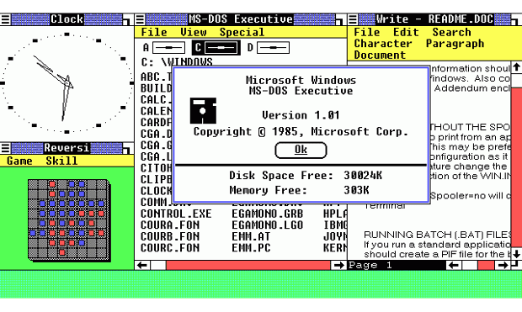

**Figure 2.2 Windows 1.0**

**(REF :** [**https://en.wikipedia.org/wiki/Windows_1.0**](https://en.wikipedia.org/wiki/Windows_1.0)**)**

The first version of Windows was released on November 20, 1985, achieving little popularity. Windows 1.0 is not a complete operating system, but rather an "operating environment" that extends MS-DOS. The first version of Microsoft Windows such as paint, Windows Write, a simple word processor; calendar, notepad, clock, control panel, clipboard, and RAM driver.

In the development of Windows 1.0, Microsoft deliberately limited the borrowing of certain GUI elements from the interface. For example, the window is only displayed "tile" on the screen; that is, they cannot overlap or overlap with each other.

1. **Windows 2.0**

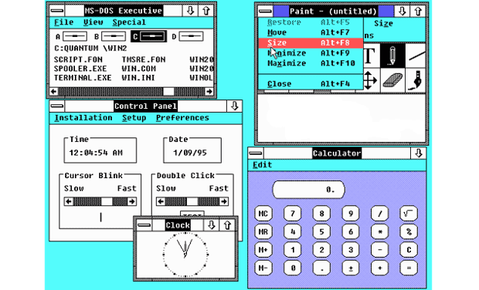

**Figure 2.3 Windows 2.0**

**(REF :** [**https://id.wikipedia.org/wiki/Windows_2.0**](https://id.wikipedia.org/wiki/Windows_2.0)**)**

Microsoft Windows version 2.0 was released in November 1987, and is more popular than its predecessor. The popularity of Windows 2.0 rises because of the new application called, Excel and Word. The big innovation for Windows 2 is that windows can overlap, and also introduce the ability to minimize or maximize windows rather than "iconizing" or "zooming".

Microsoft Windows version 2.0 uses a real-mode memory model, which limits a maximum of 1 megabyte of memory. In such a configuration, this can be run under other multitaskers such as DESQview, which uses protected mode 286.

1. **Windows 3.0**

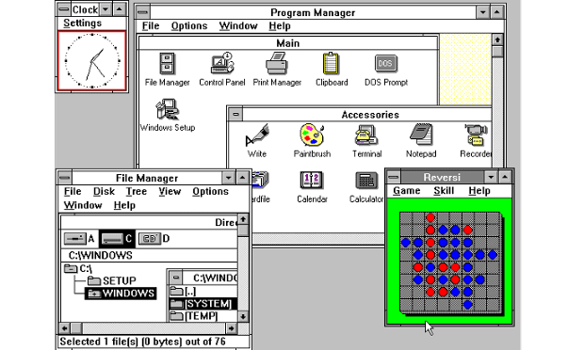

**Figure 2.4 Windows 3.0**

**(REF :** [**https://en.wikipedia.org/wiki/Windows_3.0**](https://en.wikipedia.org/wiki/Windows_3.0)**)**

Windows 3.0 was released on May 1990, the Windows 3.0 user interface finally resembled a serious competitor with the Macintosh computer user interface. Windows 3 introduces the ability to run MS-DOS programs on windows, which brings multitasking to legacy programs, and supports 256 colors that bring more modern and more colorful looks to the interface.

The features listed above and the growing market support from application software developers made Windows 3.0 very successful, selling around 10 million copies in the phase of two years before the release of version 3.1.

1. **Windows 3.1**

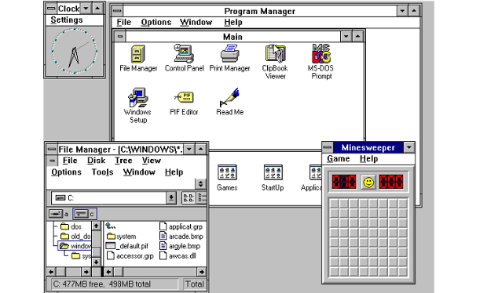

**Figure 2.5 Windows 3.1**

**(REF :**[**https://en.wikipedia.org/wiki/Windows_3.1x**](https://en.wikipedia.org/wiki/Windows_3.1x)**)**

Windows 3.1 was released with several improvements to Windows 3.0, such as the appearance of TrueType-sized fonts, multimedia support, and bug fixes.

Minesweeper also made its first appearance. Windows 3.1 requires 1MB of RAM to run and allows supported MS-DOS programs to be controlled with the mouse for the first time. Windows version 3.1 still lacks most important features, such as long file names, desktops, or system protection against inappropriate applications.

1. **Windows NT 3.x**

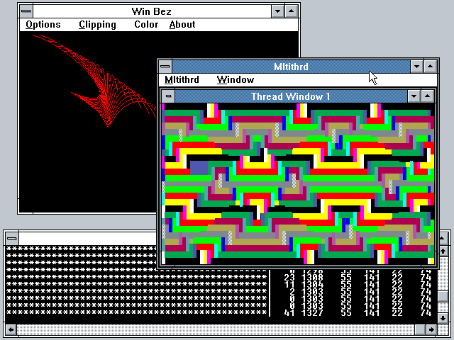

**Figure 2.6 Windows NT 3.x**

**(REF :** [**https://winworldpc.com/product/windows-nt-3x/nt-os-2**](https://winworldpc.com/product/windows-nt-3x/nt-os-2)**)**

Microsoft continues to develop Windows NT by paying US $ 150 million and agreeing to support the Alpha DEC CPU chip in NT. One of Microsoft's biggest advances originally developed for Windows NT is the new 32-bit API, to replace the old 16-bit Windows API.

As released, Windows NT 3.x goes through three versions (3.1, 3.5, and 3.51), mainly internal changes and reflects changes in the back end. Release of 3.5 add supports for the new types of hardware and increased performance and data reliability. Then, the release of 3.51 is primarily to update the Win32 API to be compatible with software written for the Win32c API which later became Windows 95.

1. **Windows 95**

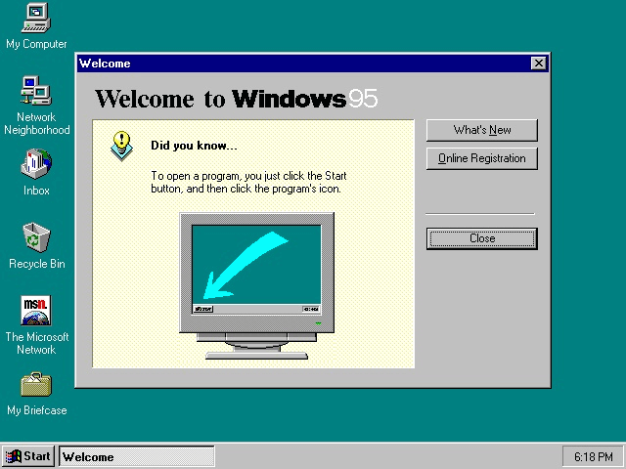

**Figure 2.7 Windows 95**

**(REF :** [**https://en.wikipedia.org/wiki/Windows_95**](https://en.wikipedia.org/wiki/Windows_95)**)**

Windows 95 was released by adding the Start button and the first Start menu. Internet Explorer was first released on Windows 95 but was not installed by default in the operating system which requires Windows 95 Plus.

Then, Microsoft released five versions of Windows 95:

1. Windows 95
2. Windows 95 A
3. Windows 95 B
4. Windows 95 B USB
5. Windows 95 C
6. **Windows NT 4.0**

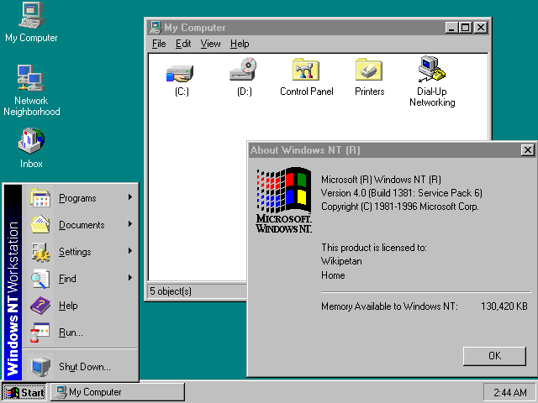

**Figure 2.8 Windows NT 4.0**

**(REF :** [**https://en.wikipedia.org/wiki/Windows_NT_4.0**](https://en.wikipedia.org/wiki/Windows_NT_4.0)**)**

Windows NT 4.0 is the next generation of 3.5 and 3.51. The main new features include the Internet Explorer shell from Windows 95, scalability and feature enhancements. One of the more important new features is the addition of Internet Connection Sharing, a form of network address translation, which allows several machines on a LAN (Local Area Network) to share one Internet connection to the other devices.

Windows NT 4.0 comes in four versions:

1. Windows NT 4.0 Workstation
2. Windows NT 4.0 Server
3. Windows NT 4.0 Server, Enterprise Edition
4. Windows NT 4.0 Terminal Server
5. **Windows 98**

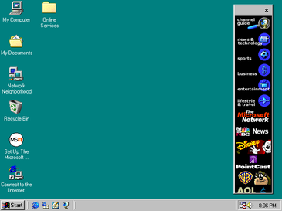

**Figure 2.9 Windows 98**

**(REF :** [**https://en.wikipedia.org/wiki/Windows_98**](https://en.wikipedia.org/wiki/Windows_98)**)**

Windows 98 was released on June 1998 with Internet Explorer 4, Outlook Express, Windows Address Book, Microsoft Chat and NetShow Player. And then the USB support is much better in Windows 98 and has led to widespread adoption, including USB hubs and USB mouse.

1. **Windows 2000**

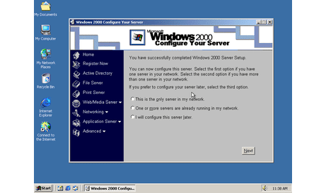

**Figure 2.10 Windows 2000**

**(REF :** [**https://en.wikipedia.org/wiki/Windows_2000**](https://en.wikipedia.org/wiki/Windows_2000)**)**

Microsoft released Windows 2000 on February 17, 2000. Features of Windows 98 were also included, such as an improved Device Manager, Windows Media Player, and a revised DirectX that made it possible for the first time for many modern games to work on the NT kernel. Microsoft's automatic updates play an important role in Windows 2000 and become the first Windows to support hibernation.

Windows 2000 was available in four editions:

1. Windows 2000 Professional
2. Windows 2000 Server
3. Windows 2000 Advanced Server
4. Windows 2000 Datacenter Serve
5. **Windows ME**

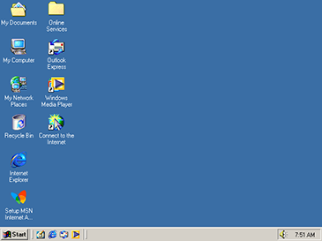

**Figure 2.11 Windows ME**

**(REF :** [**https://en.wikipedia.org/wiki/Windows_Me**](https://en.wikipedia.org/wiki/Windows_Me)**)**

In September 2000 Windows released a new version called Windows Me, short for "Millennium Edition". It was the last DOS-based operating system from Microsoft. Windows Me introduces a new multimedia editing application called Windows Movie Maker and Windows Media Player 7.

Windows Me was conceived as a one-year fast project that served as a temporary release between Windows 98 and Windows XP. Windows Me was criticized for stability issues, as well as a lack of real DOS mode support, to the point of being called "Fail Edition".

1. **Windows XP**

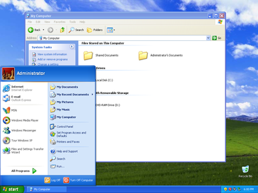

**Figure 2.12 Windows XP**

**(REF :** [**https://en.wikipedia.org/wiki/Windows_XP**](https://en.wikipedia.org/wiki/Windows_XP)**)**

Windows XP was released in October 2000, the Start Menu and the taskbar get a visual overhaul, bringing the green Start button, blue taskbar, and vista wallpaper, along with various shadows and other visual effects.

ClearType, which is designed to make the text easier to read on an LCD screen. Windows XP is the longest-running Microsoft operating system, in the phase of three major updates and supports until April 2014 - 13 years from the original release date. Although it is very popular, Windows XP has a firewall in it but it is easy to turn off, this makes Windows XP less secure.

1. **Windows Vista**

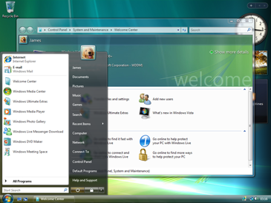

**Figure 2.13 Windows Vista**

**(REF :** [**https://en.wikipedia.org/wiki/Windows_Vista**](https://en.wikipedia.org/wiki/Windows_Vista)**)**

Windows Vista was released on January 2007. Vista is updating the look and feel of Windows by focusing more on transparent elements, search, and security. Windows Media Player 11, Internet Explorer 7, and Windows Defender were released together at the same time. Vista also includes voice recognition, Windows DVD Maker and Photo Gallery.

Windows Vista has six editions:

1. Starter (only available in developing countries)
2. Home Basic
3. Home Premium
4. Business
5. Enterprise (only available to large business and enterprise)
6. Ultimate (combines both Home Premium and Enterprise)
7. **Windows 7**

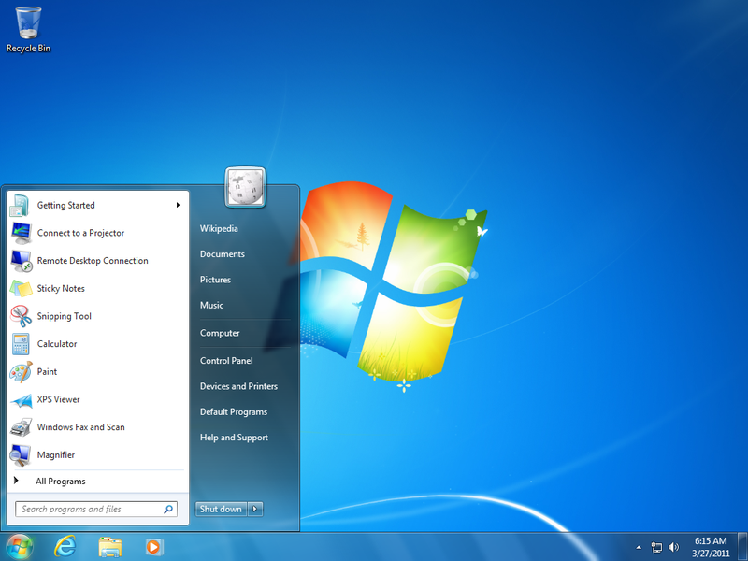

**Figure 2.14 Windows 7**

**(REF :** [**https://en.wikipedia.org/wiki/Windows_7**](https://en.wikipedia.org/wiki/Windows_7)**)**

Windows 7 was first released in October 2009. It was intended to fix all the problems and criticism faced by Vista, with slight tweaks to its appearance and a concentration on user-friendly features. Windows 7 was faster, more stable and easier to use, becoming the operating system most users and business would upgrade to from Windows XP.

Windows 7 has six editions:

1. Starter (available worldwide)
2. Home Basic
3. Home Premium
4. Professional
5. Enterprise (available to volume-license business customers only)
6. Ultimate
7. Home Premium and Professional
8. **Windows 8**

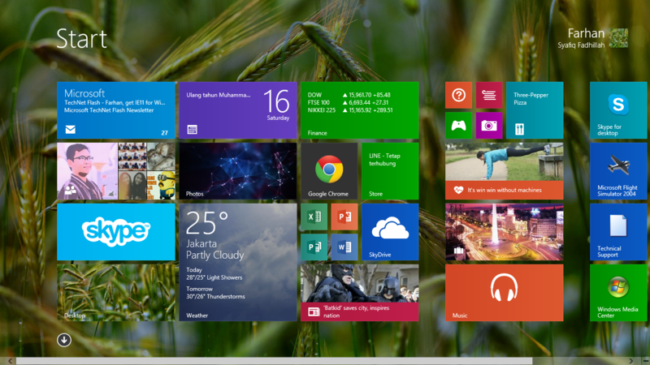

**Figure 2.15 Windows 8**

**(REF :** [**https://en.wikipedia.org/wiki/Windows_8**](https://en.wikipedia.org/wiki/Windows_8)**)**

Released on October 2012, Windows 8 was Microsoft’s most radical overhaul of the Windows interface, ditching the Start button and Start menu in favor of a more touch-friendly Start screen.

Windows 8 was faster than previous versions of Windows and included support for the new, much faster USB 3.0 devices. The Windows Store, which offers universal Windows apps that run in a full-screen mode only, was introduced. Programs could still be installed from third-parties like other iterations of Windows, but they could only access the traditional desktop interface of Windows.

Windows RT, which runs on ARM-based processors traditionally found in smartphones and non-PC tablets, was introduced at the same time as Windows 8 with the Microsoft Surface tablet. It looked and felt like Windows 8, but could not run traditional Windows applications, instead solely relying on the Windows Store for third-party apps.

Windows 8 has 4 editions:

1. Windows 8
2. Windows 8 Pro
3. Windows 8 Enterprise
4. Windows RT
5. **Windows 8.1**

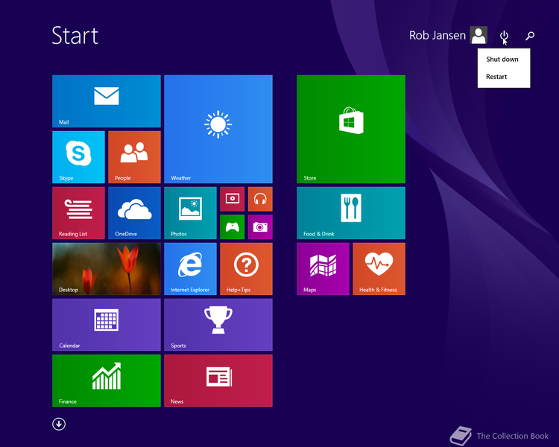

**Figure 2.16 Windows 8.1**

**(REF :** [**https://en.wikipedia.org/wiki/Windows_8.1**](https://en.wikipedia.org/wiki/Windows_8.1)**)**

A free point release to Windows 8 introduced in June 2013, Windows 8.1 marked a shift towards yearly software updates from Microsoft and included the first step in Microsoft’s U-turn around its new visual interface.

Windows 8.1 re-introduced the Start button, which brought up the Start screen from the desktop view of Windows 8.1. Users could also choose to boot directly into the desktop of Windows 8.1, which was more suitable for those using a desktop computer with a mouse and keyboard than the touch-focused Start screen.

1. **Windows 10**

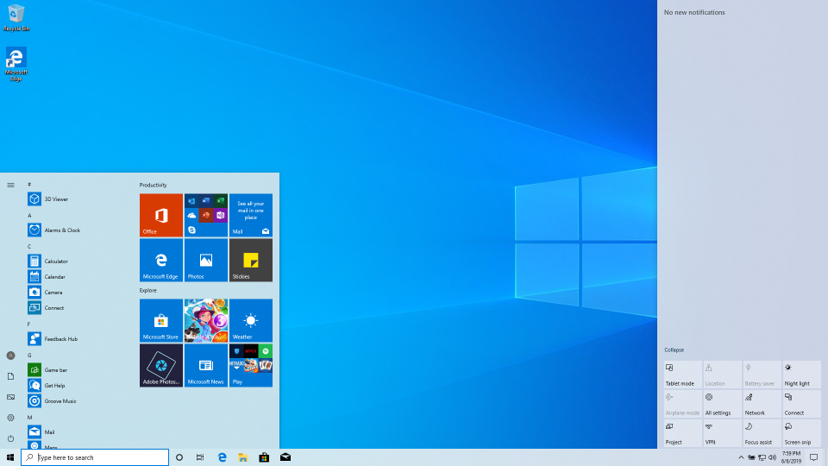

**Figure 2.17 Windows 10**

**(REF :** [**https://en.wikipedia.org/wiki/Windows_10**](https://en.wikipedia.org/wiki/Windows_10)**)**

Windows 10 is an operating system developed by Microsoft. Terry Myerson, executive vice president of Microsoft Windows and Devices Group, said that the aim of this model is to reduce fragmentation across the Windows platform. On July 29, 2015, Microsoft officially launched its newest computer operating system, Windows 10, simultaneously in 190 countries. Windows 10 is the newest OS made by Microsoft because it is an OS that can be used on a variety of devices, from PCs to the Internet of Things (IoT). Microsoft said that they have tested this latest OS on more than 2,000 different devices[6].

# **CHAPTER III PROBLEM ANALYSIS**

1. **Edition of Windows 10**

* **Home**

Windows 10 Home is designed for use in PCs, tablets and 2-in-1 PCs. It includes all features directed at consumers.

* **Pro**

Windows 10 Pro includes all features of Windows 10 Home, with additional capabilities that are oriented towards business environments, such as Active Directory, Remote Desktop, BitLocker, Hyper-V, and Windows Defender Device Guard.

* **S**

Windows 10 S is a feature-limited edition of Windows 10 designed primarily for low-end devices in the education market. It has a faster initial setup and login process, and allows devices to be provisioned using a USB drive with the "Set Up School PCs" app. Windows 10 S only allows the installation of software (both Universal Windows Platform and Windows API apps) from Microsoft Store, although command line programs or shells (even from Microsoft Store) are not allowed.

* **Education**

Windows 10 Education is distributed through Academic Volume Licensing. It was built off of Windows 10 Enterprise and initially reported to have the same feature set.

* **Enterprise**

Windows 10 Enterprise provides all the features of Windows 10 Pro. Windows 10 Enterprise is configurable on three branches, Semi-Annual Channel, Semi-Annual Channel (Targeted), and Windows Insider [7].

1. **Advantage and Disadvantage Windows 10**

**Table 3.1 Advantage and Disadvantage**

**(REF :** [**https://www.reneelab.com/advantages-disadvantages-windows-10.html**](https://www.reneelab.com/advantages-disadvantages-windows-10.html)**)**

|  |  |
| --- | --- |
| The loading time of Windows 10 is much less than that of Windows 7. | User personal information will be shared with Microsoft for better service and improvement. |
| Windows 10 UI is easy to use because UI Windows 10 integrate the advantages of Windows 7 and 8. | When Windows 7 and 8 are going to be upgraded to Windows 10 sometimes may lead system crashes. |
| It is safer because Windows 10 is the latest operating system from Windows. | Windows 10 is not compatible with old computers, because Windows 10 matches the current computer specifications. |
| Update Windows 10 with the update button will not damage or delete your files. | Windows 10 often show pop up notifications to be updated to the latest system. |

[8]

1. **Features of Windows 10**

* **Timeline**

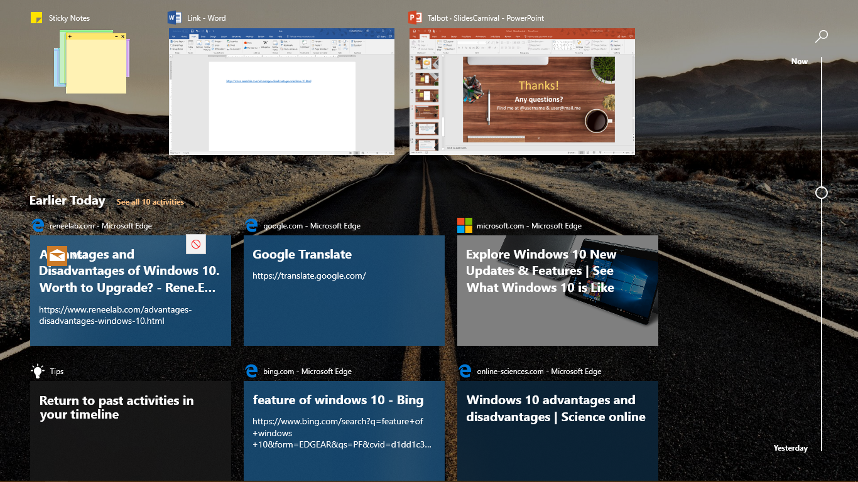

**Figure 3.1 Timeline**

User can find out what was opened the last few days.

* **Talk instead of type**

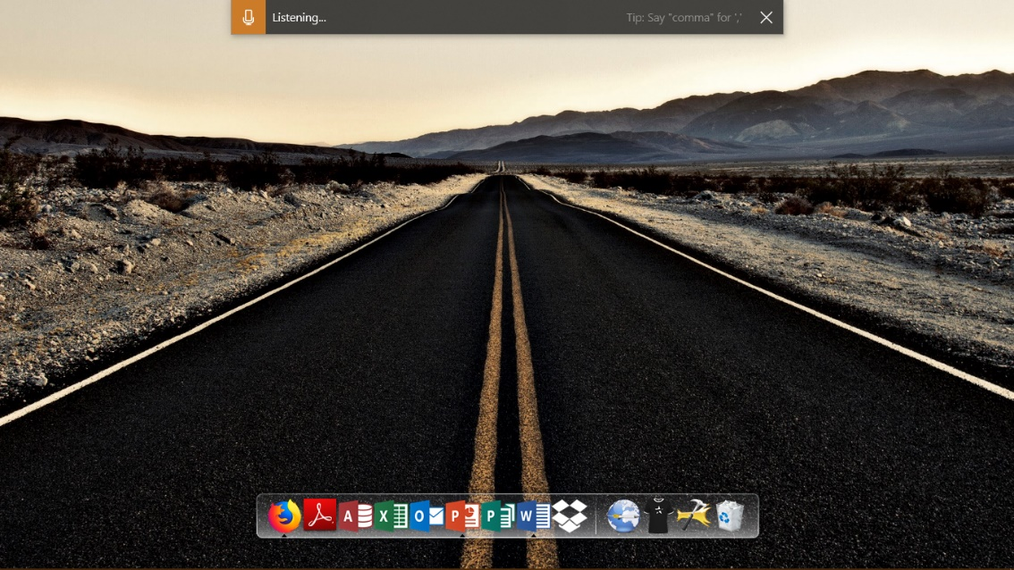

**Figure 3.2 Talk Instead of Type**

With this feature the User can type without using the keyboard. On the touch keyboard, select microphone. On a physical keyboard, press Windows logo key + H to dictate what’s on your mind.

* **Switch seamlessly from your phone to PC**

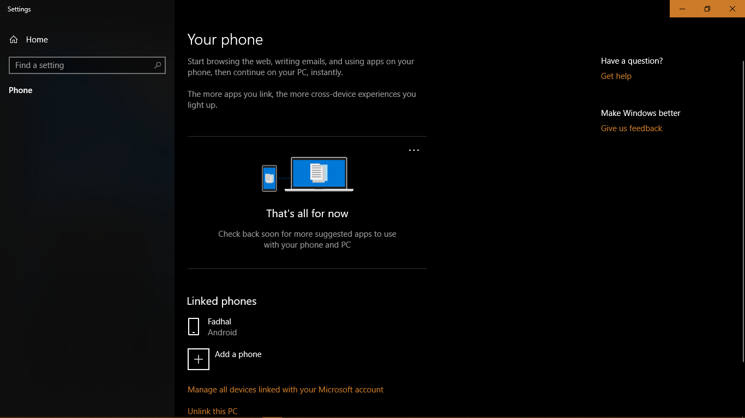

**Figure 3.3 Your Phone**

User can open any link from our phone on PC by using “Your Phone” application on our phone and computer.

* **Add emoji from your keyboard**

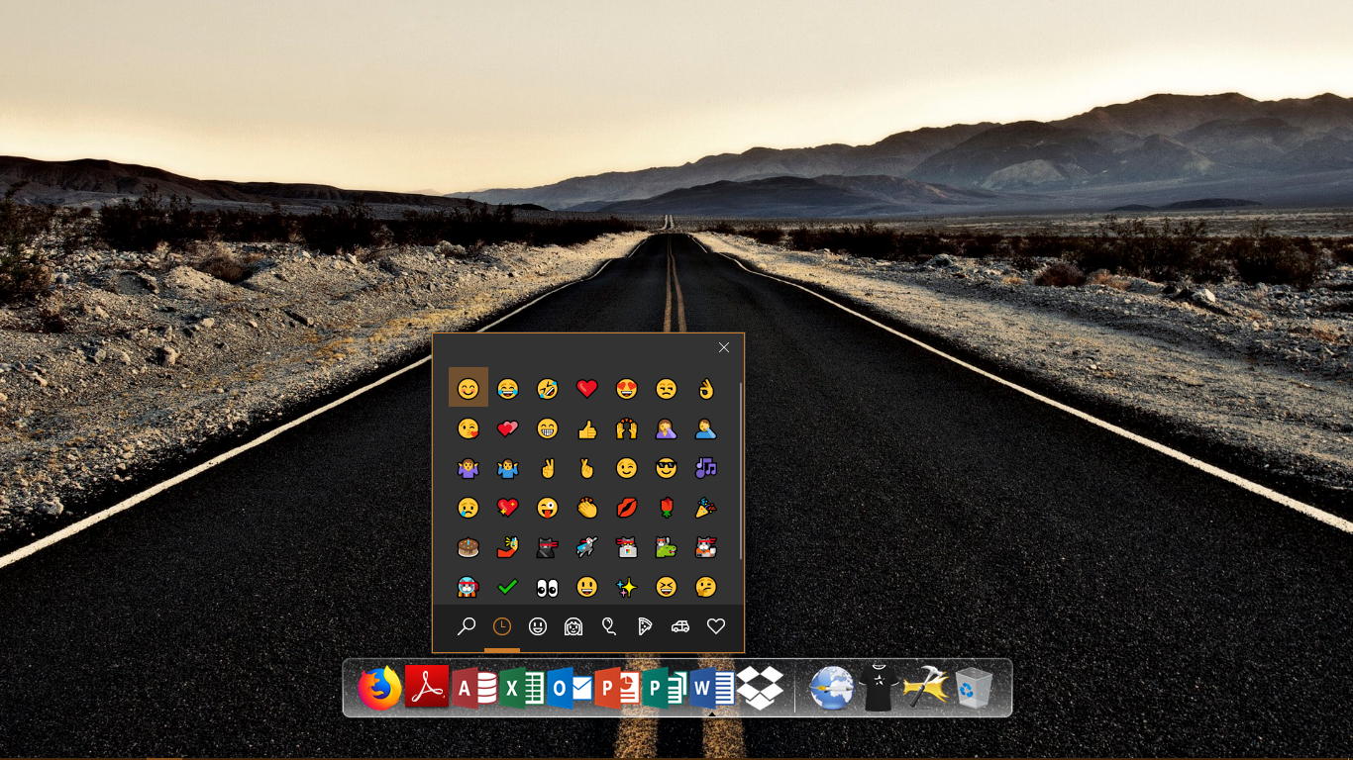

**Figure 3.4 Add Emoji**

User can add emoji on PC by using Windows button + Period (.).

* **Focus Assist**

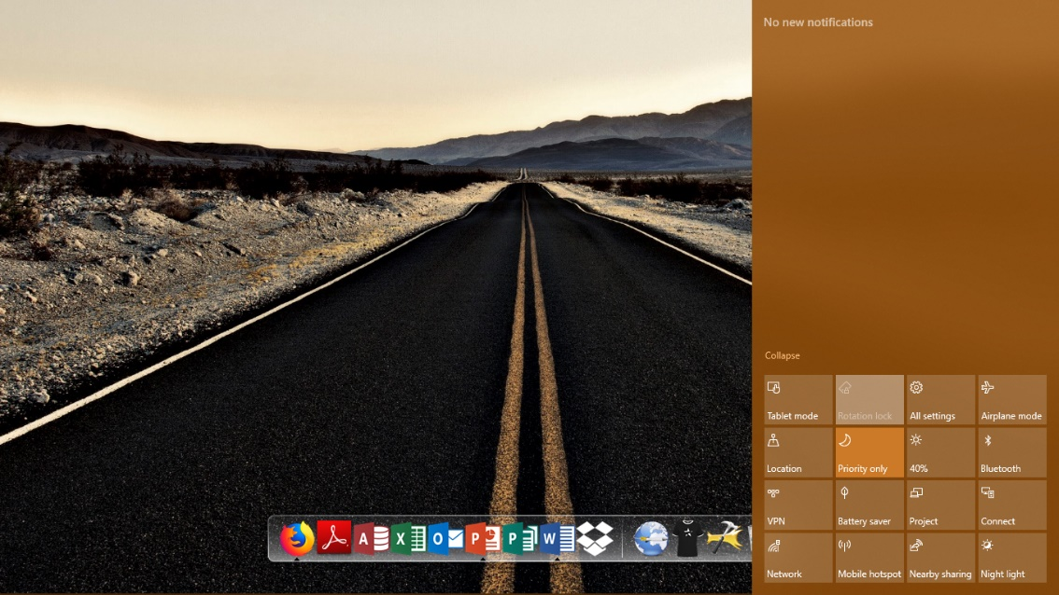

**Figure 3.5 Focus Assist**

when the user of windows 10 are doing something and dont want to be disturbed can use this feature. this feature is useful to turn off the notifications. user can set it to become "priority only" or "Alarms only"

**CHAPTER IV CONCLUSION AND SUGGESTION**

1. **Conclusion**

From this ISAS, writers can conclude that for now, Windows 10 is the latest and one of the best Windows ever released by Microsoft. With features that make it easy for users to do activities, sophisticated user interface, the price offered is following the usability.

1. **Suggestion**

If you want to use Windows 10, writers recommends using Windows 10 Pro because it has features that meet the needs of all users. However, if the user needs to focus on certain needs, many editions of Windows 10 can be chosen by the user.

# **BIBLIOGRAPHY**

[1] [Techopedia] [What is an Operating System (OS)?] <https://www.techopedia.com/definition/3515/operating-system-os> [07/09/2019]

[2] [Cleverism] [What Is an Operating System (OS) and How Does It Work] [27/11/2016] <https://www.cleverism.com/operating-system-os-guide/> [07/09/2019]

[3] [MyBroadband] [Windows 1.0 to Windows 10: from the first to the last Windows] [31/07/2015] <https://mybroadband.co.za/news/software/133728-windows-1-0-to-windows-10-from-the-first-to-the-last-windows.html> [08/09/2019]

[4] [Microsoft] [How to Check Windows 10 Computer System Specs & Requirements] <https://www.microsoft.com/en-us/windows/windows-10-specifications> [09/09/2019]

[5] [SearchEnterpriseDesktop] [What is Microsoft Windows 10?] <https://searchenterprisedesktop.techtarget.com/definition/Windows-10> [09/09/2019]

[6] [Tech Industry] [Microsoft Windows Version History] [23/06/2019] <https://www.conspros.app/2019/06/21/microsoft-windows-version-history/> [09/09/2019]

[7] [Windowku] [Inilah Macam Macam Windows 10 Berdasarkan Edisinya Lengkap!] [22/05/2018] <https://windowsku.com/macam-macam-windows-10-berdasarkan-edisi/> [10/09/2019]

[8] [Rene.E Laboratory] [Advantages and Disadvantages of Windows 10. Worth to Upgrade?] [16/10/2017] <https://www.reneelab.com/advantages-disadvantages-windows-10.html> [10/09/2019]